Grad Group Project: Decision Trees in Bended Attributes and Shifted Paired Coordinates

Andrew Dunn, Justin Phan Phan, Sichong Qin,

Brad Reeves, Sridevi Wagle



Department of Computer Science

Central Washington University

November 9, 2020

# **1 Objectives**

## 1.1 Decision Trees in Bended Attributes

The main objectives are:

* Write a generalized code to implement decision trees in bended attributes and Shifted Paired Coordinates.
* Write code to generate the bended attributes and Shifted Paired Coordinates from the description of the decision tree obtained in Tanagra.
* Parse Tanagra description of the DT for the attributes.
* Allow generalized program to show all n-D points from a given dataset (read this dataset from the file).
* Make UI interface that will allow to show for the given datasets:
* all training n-D points that go from the root to the **given terminal node**,
* all validation n-D points that go from the root to the given terminal node,
* all training n-D points that go from the root to **all terminal nodes**,
* all validation n-D points that go from the root to all terminal nodes,
* highlight a user selected n-D point (to be predicted) to see how it is related to other cases in the same branch or other branches.
* Experiment with 3 datasets from Machine Learning Repository from University of California Irvine (find by search in Google).
* Compare DT visualizations of two projects in the same data (clarity, occlusion, usability).

# 2 Implementation

## 2.1 Decision Trees in Bended Attributes

This project was implemented using a tool called Godot 3.2.3. For much more information on the details of this project, please read the included user guide. This section will instead showcase the general features of the application.

Figure 2.1.1 shows the basic application window with a Decision Tree JSON file loaded. This tree was generated using Tanagra and then converted to the correct file format using Brad Reeve’s tana2tree library.

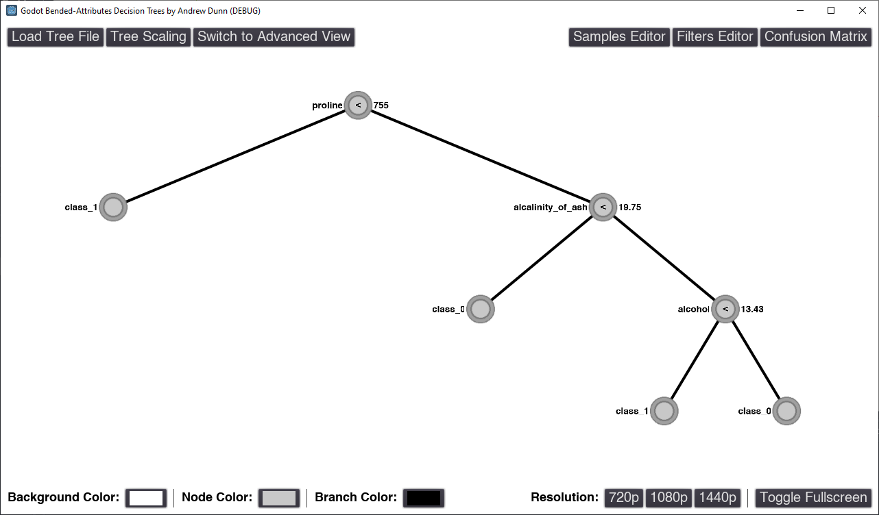

Figure 2.1.1: Decision Tree Visualization trained on Wine Dataset

Figure 2.1.2 shows the same decision tree after the test set dataset has been loaded. The application defaults to “Simple View”, which shows a general distribution of samples across the tree nodes, as well as their predictions.

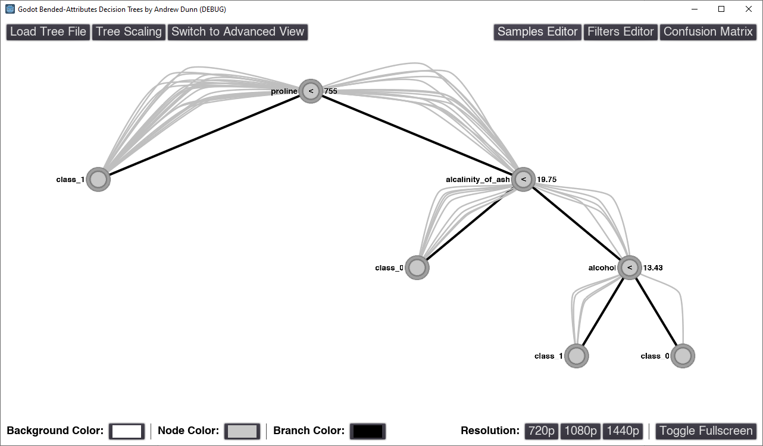

Figure 2.1.2: Decision Tree Visualization with Test Set Sample Data Overlayed (Simple View)

Figure 2.1.3 shows the same dataset, but in Advanced View. Advanced View displays the data in a Shifted Bended Attributes representation, which visually encodes the distances between sample attributes and the tree node thresholds.

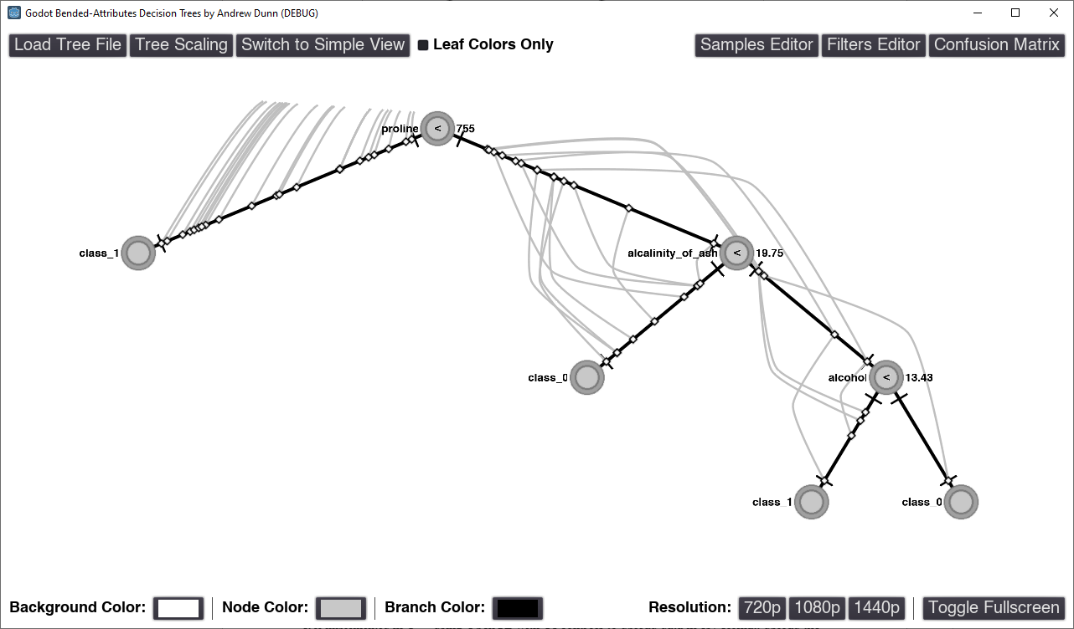

Figure 2.1.3: Decision Tree Visualization with Test Set Sample Data Overlayed (Advanced View)

Figure 2.1.4 shows the same dataset, but now the target classes have been color coded, with blue representing class 1 and red representing class 0. Note that the “Leaf Colors Only” checkbox is checked, which changes the colors of non-leaf sample lines to gray.

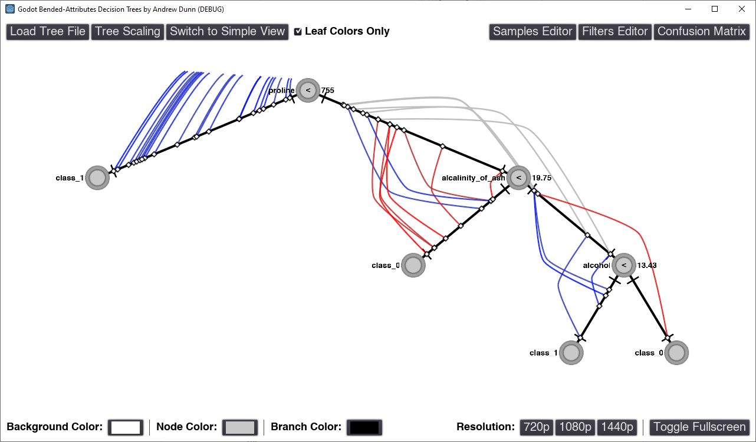

Figure 2.1.4: Advanced View with Colors Assigned for Class Targets

Figure 2.1.5 shows the same dataset, but the samples have had a filter applied that only shows incorrectly classified samples. For this tree and dataset, we can see that two class 1 samples were incorrectly classified as class 0.

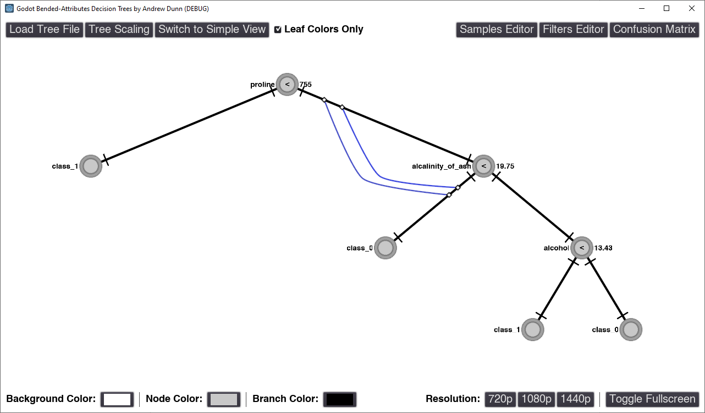

Figure 2.1.5: Advanced View Showing Only Incorrectly Classified Samples (Filtered)

Figure 2.1.6 shows the confusion matrix feature after it was applied to the full dataset.

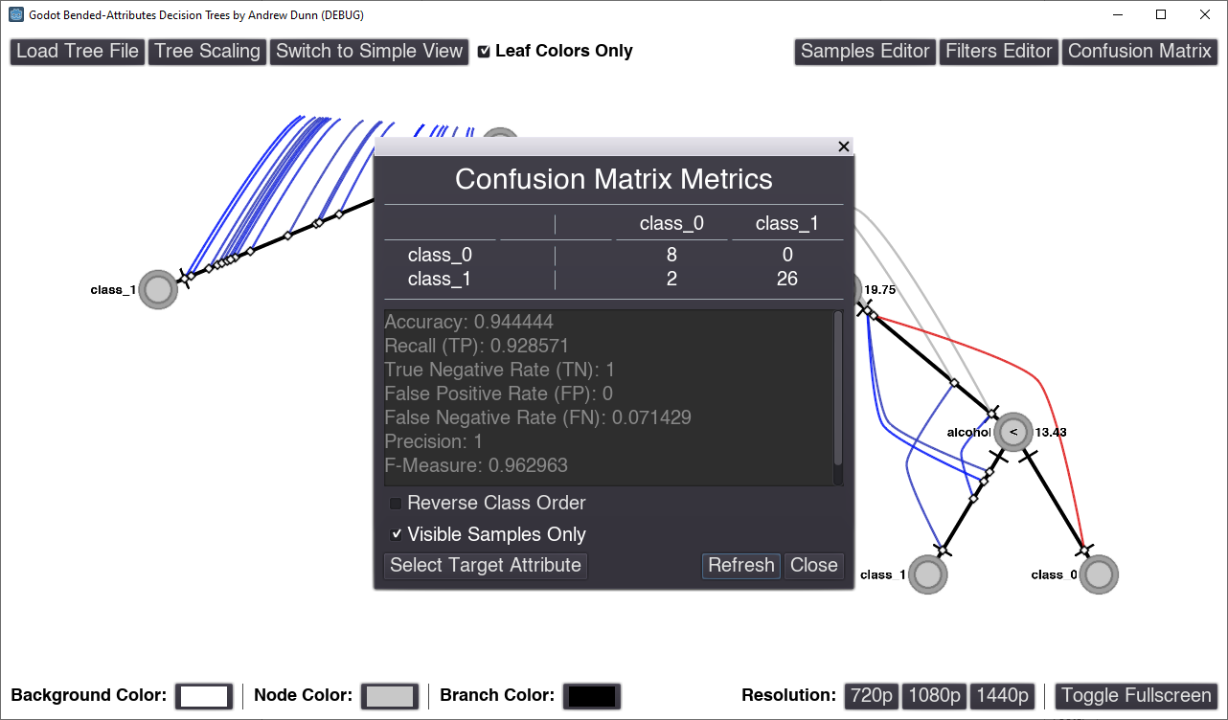

Figure 2.1.6: Confusion Matrix Metrics for Entire Test Dataset

Figure 2.1.7 shows how individual samples can be managed and edited using the Samples Editor window. This allows the user to change sample data, change their visibility in the decision tree, change their color, and load additional samples from a CSV file.

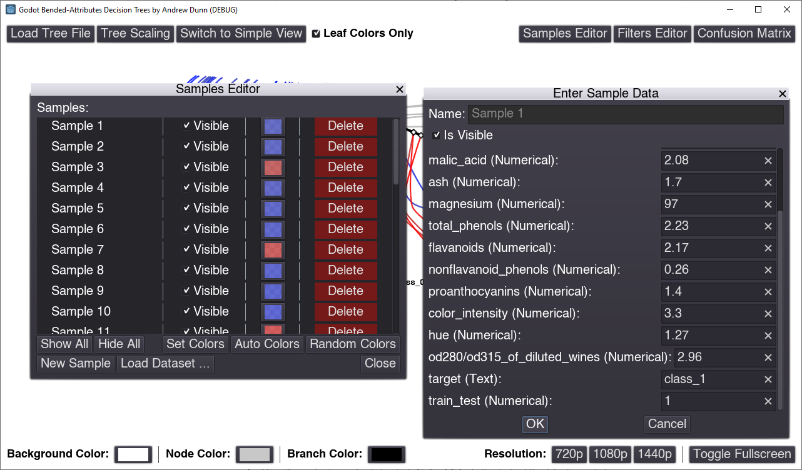

Figure 2.1.7: Advanced View Showing Only Incorrectly Classified Samples (Filtered)

Figure 2.1.8 shows the Filter Samples window, and how complex filters can be created and modified. Filters are created using a logical conditional expression and can reference any sample attribute or class prediction. This allows the user to look for patterns by creating various filters and applying various colors to filtered samples.

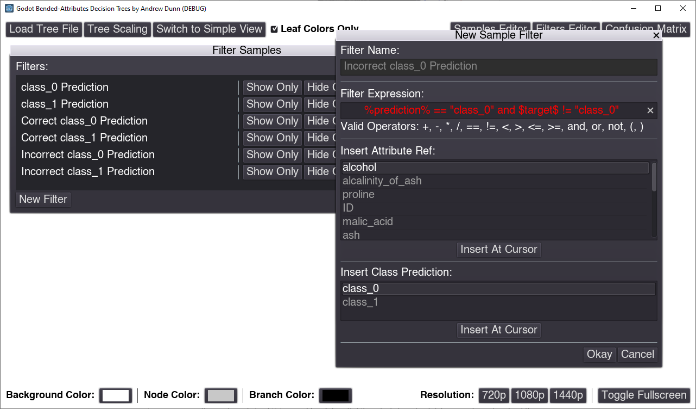

Figure 2.1.8: Filters Editor Showing Filter Expression for Incorrect Class 0 Predictions

Figure 2.1.9 shows the same decision tree after it has been scaled by up by 2x. Scaling the tree can be useful if you have many closely clustered samples.

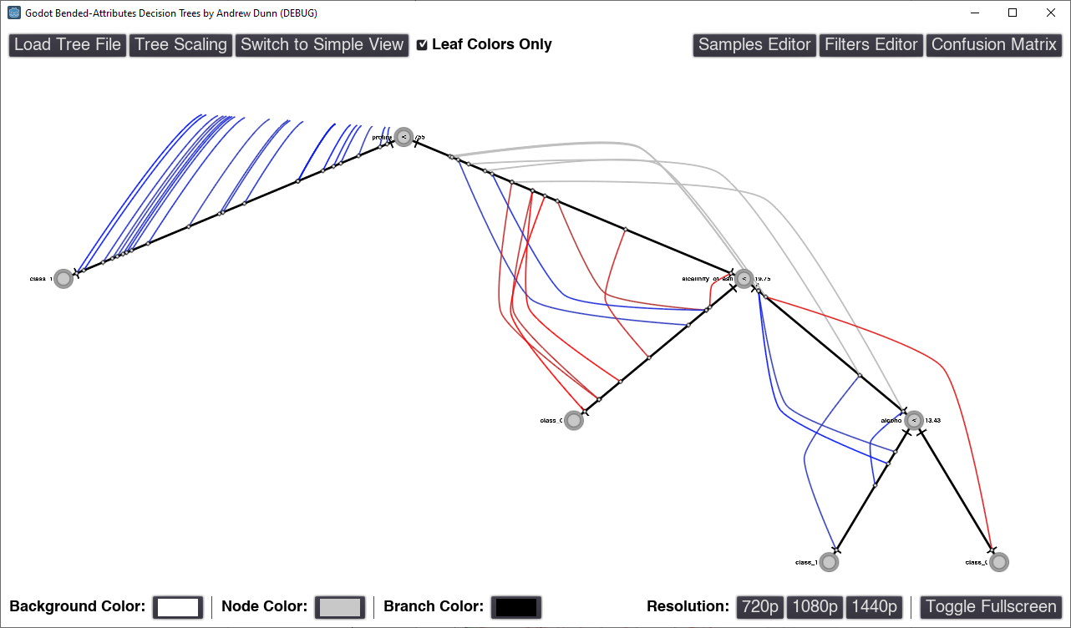

Figure 2.1.9: Decision Tree Visualization with 2X Scaling Factor

## 2.2 Decision Trees in Shifted Paired Coordinates (SPC)

It is implemented in C++ using OpenGL with UI controls to upload data in csv format, upload the parser file, display training data, testing data etc. Below are the instructions to run the software:

* Access the solution folder -> Release -> OpenGL_on_a_Windows_Form application file.
* Once the application is loaded, select ‘**Upload File**’ button to load the data. Figure below visualizes breast cancer data (8 attributes) in Shifted Paired Coordinates.

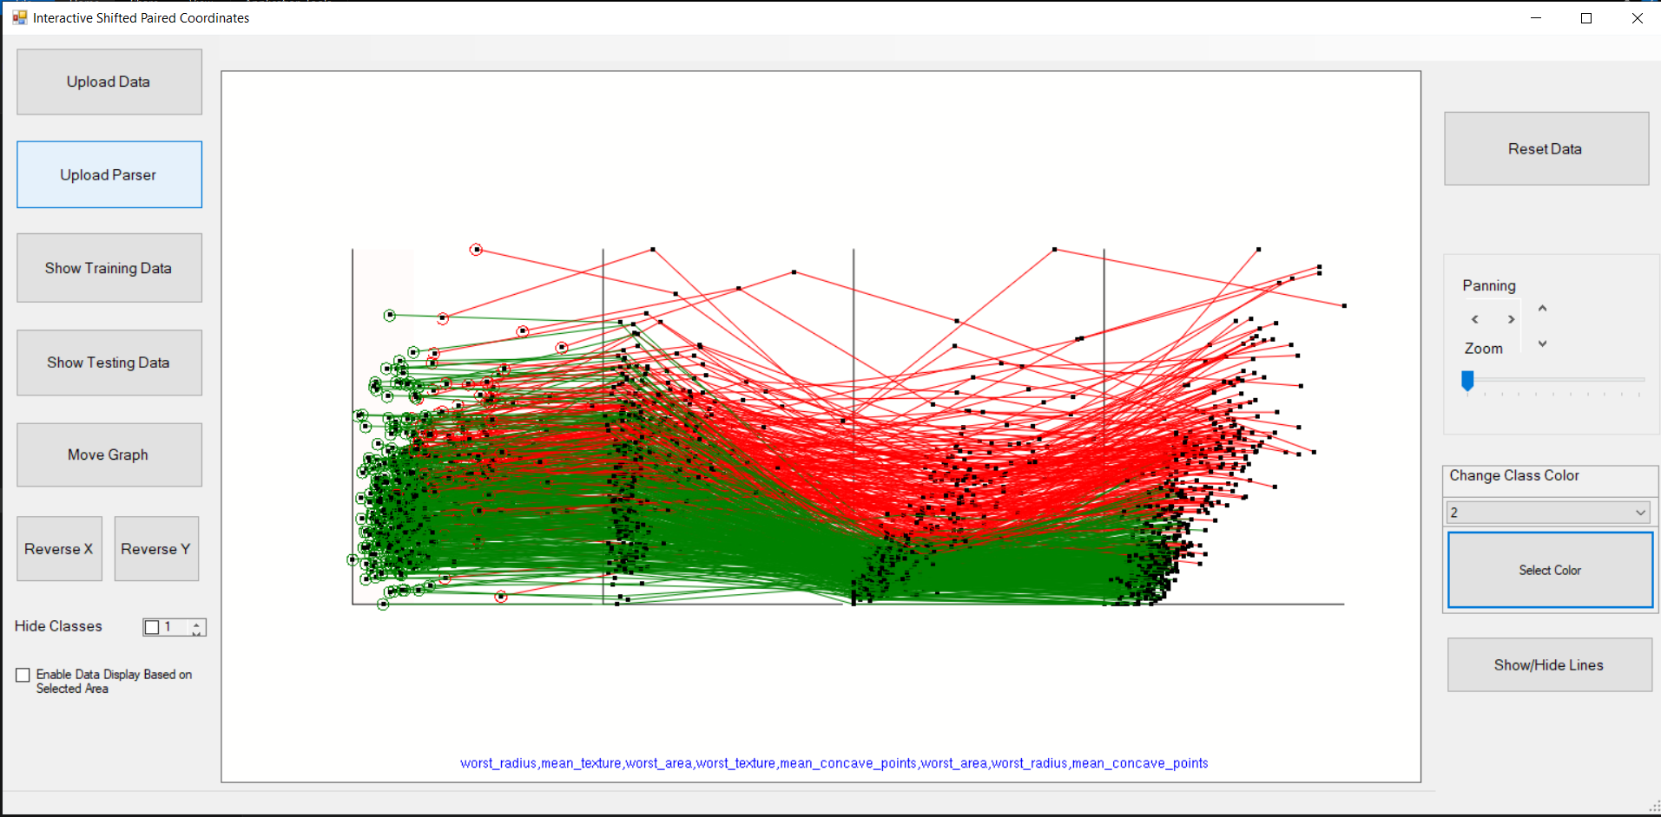

Figure 2.2.1: Breast Cancer data (8-D) in Shifted Paired Coordinates

* Select ‘Upload Parser’ option to load the Tanagra output in the form of .txt file. The parser file for breast cancer data is available under Release folder. Upon loading the parser file, rectangular areas are displayed as shown in figure below:

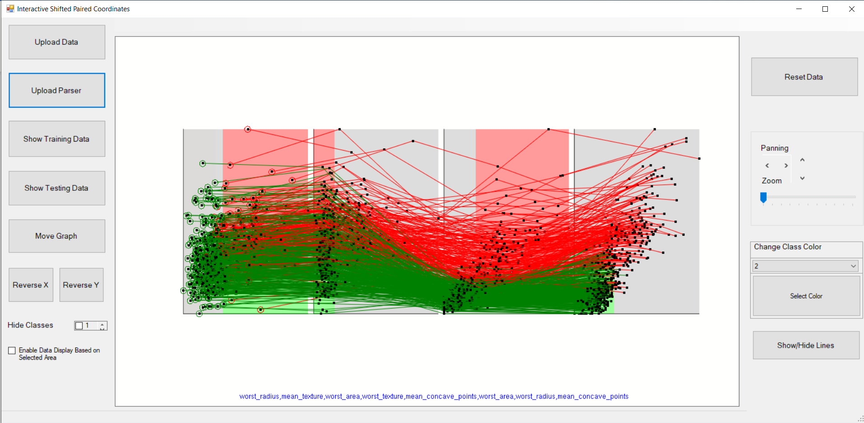

Figure 2.2.2: Visualization of Breast Cancer Data after loading the Parser file

* The ‘Show Training Data’ displays 80% of the dataset as shown in figure below:

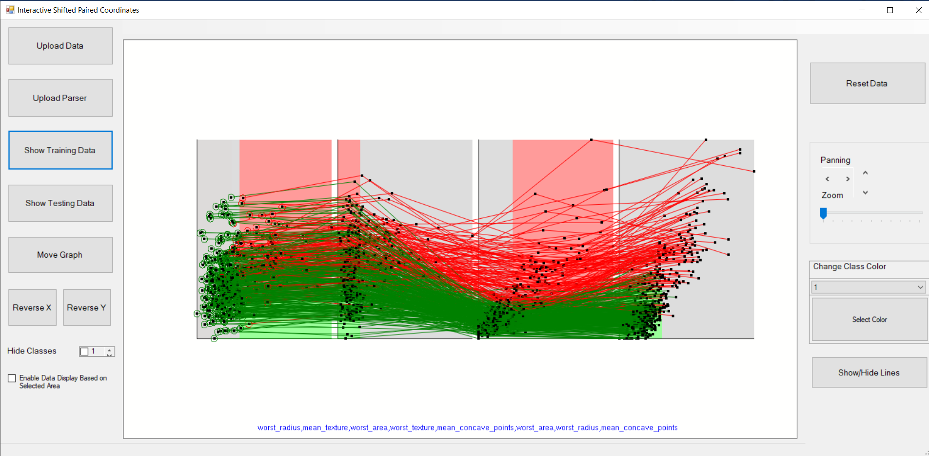

Figure 2.2.3: Visualization of training breast cancer data (80%)

* The ‘Show Testing Data’ displays 20% of the dataset as shown in figure below:

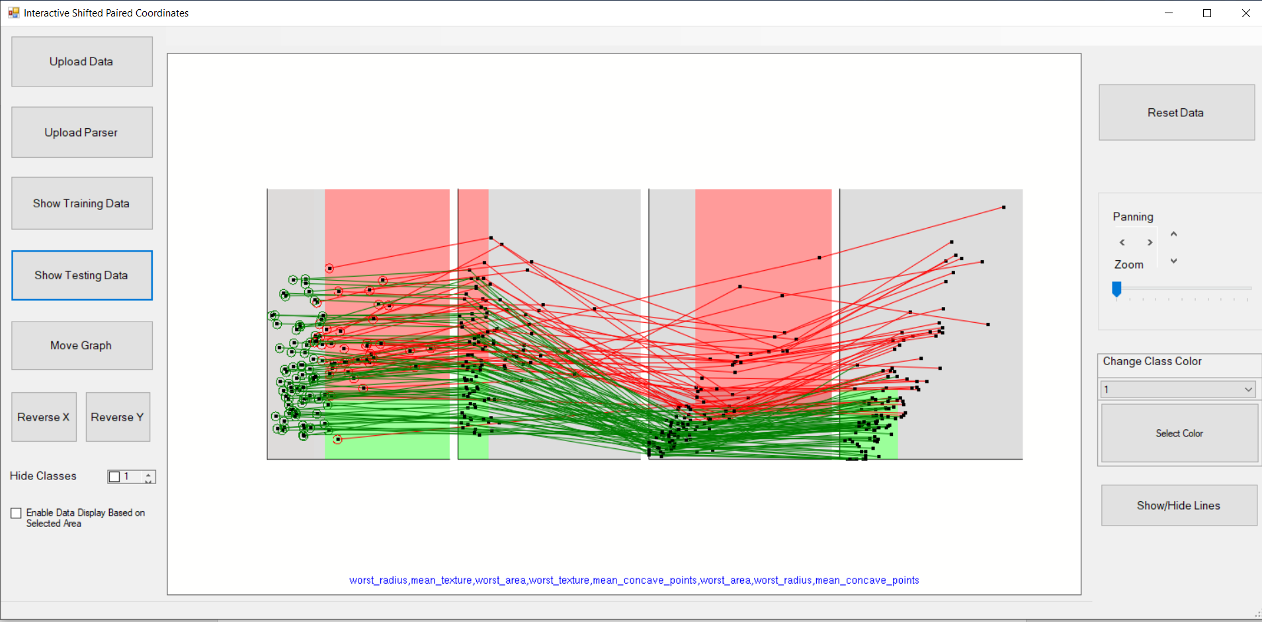

Figure 2.2.4: Visualization of training breast cancer data (20%)

* ‘Move Graph’ option repositions the selected graph with mouse drag-and-drop action.

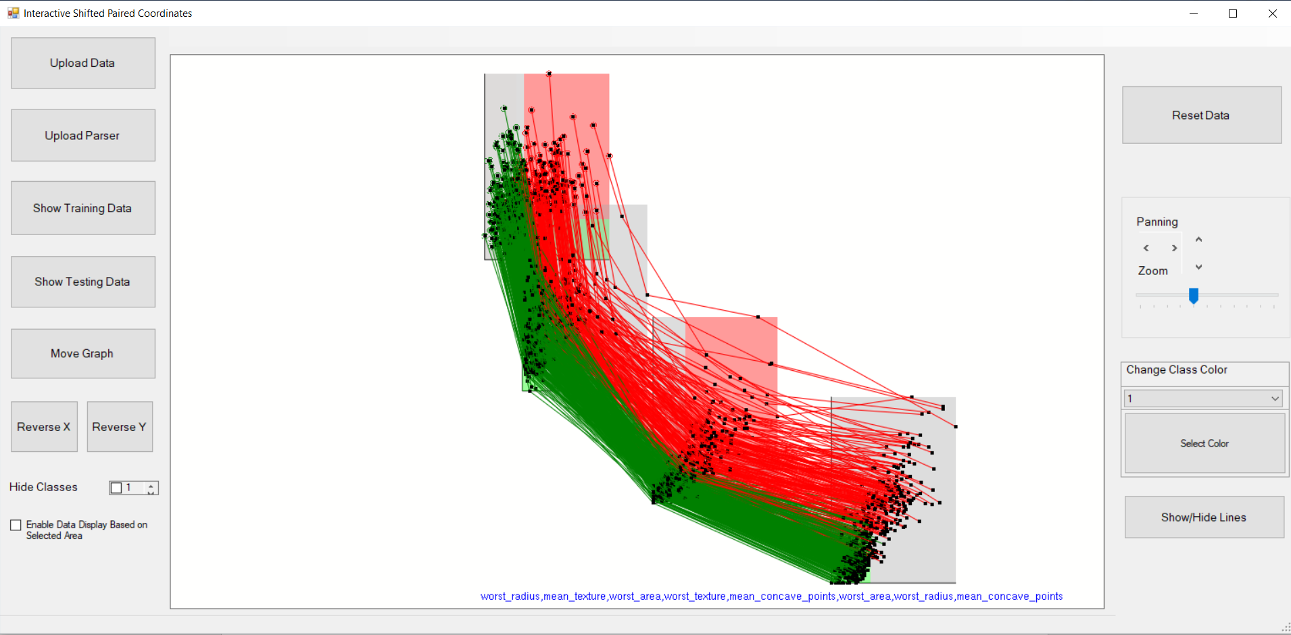

Figure 2.2.4: Visualization of breast cancer data after moving the graphs

* ‘Hide Classes’ option hides user selected class.

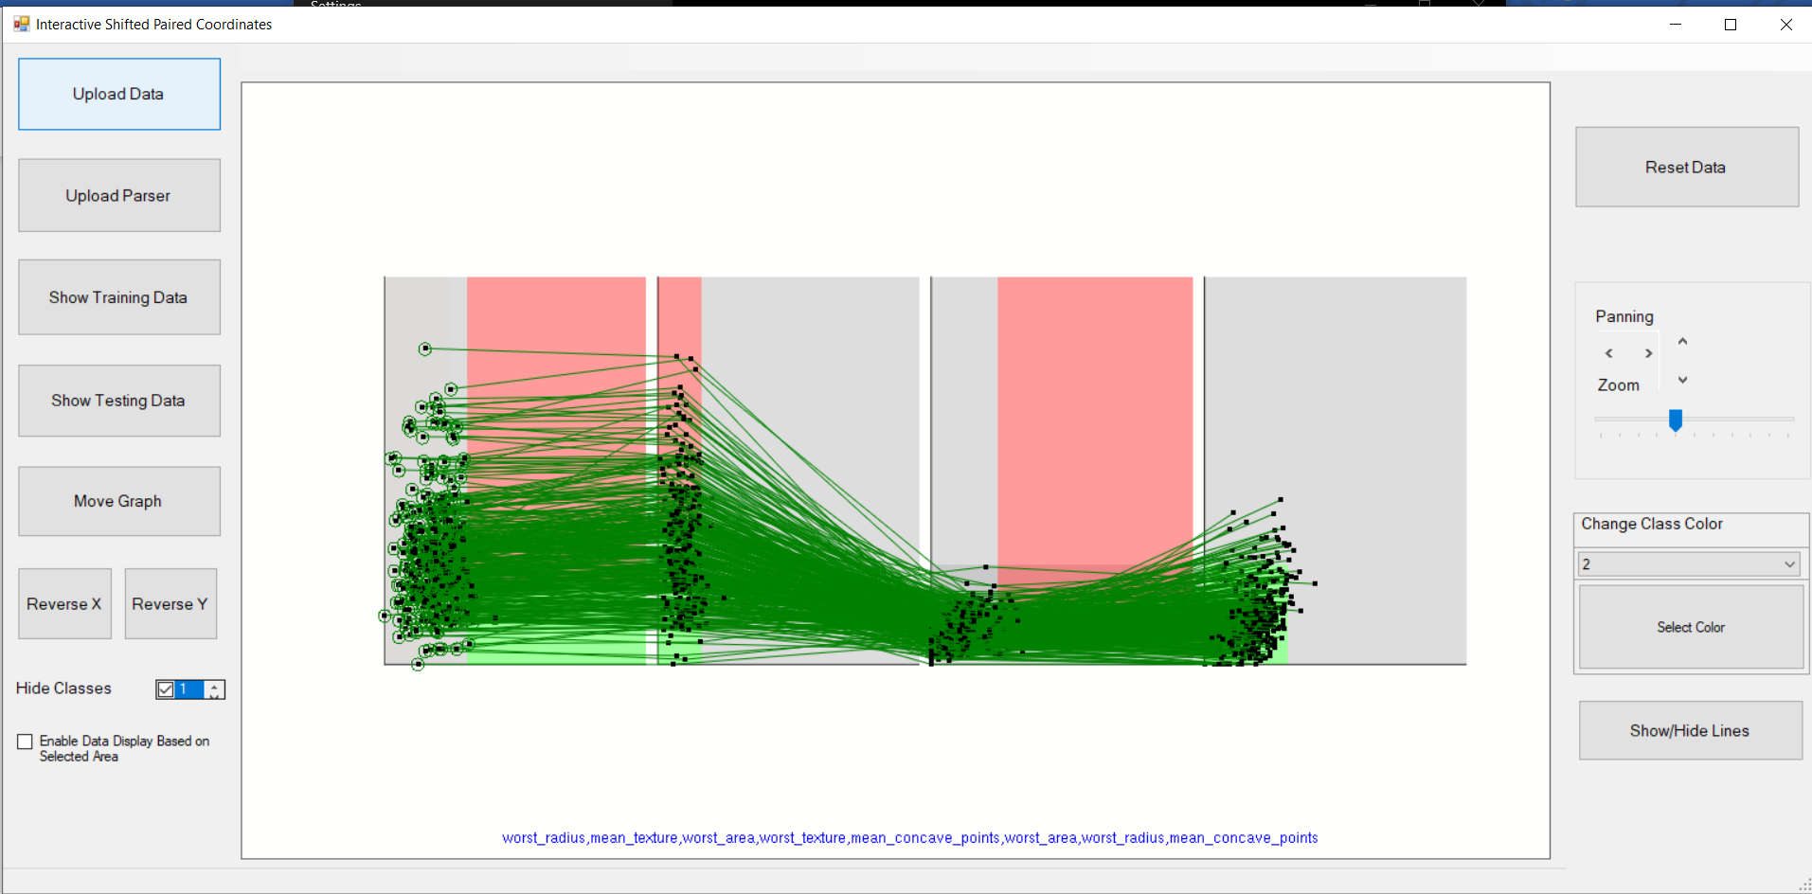

Figure 2.2.4: Visualization of breast cancer data after hiding class 1 data.

* Reverse X and Y option performs data reversing. For instance, if **x** is an n-D point where **x** = (*x­*1, *x­*2, *x­*3,…… *x­*n), reverse of *x­*1 would redisplay the data as **x** = (1 - *x­*1, *x­*2, *x­*3,…… *x­*n).

‘Reverse X’ button reverses the horizontal coordinates of the selected cartesian coordinate pair and ‘Reverse Y’ button reverses the vertical coordinates of the selected cartesian coordinate pair.

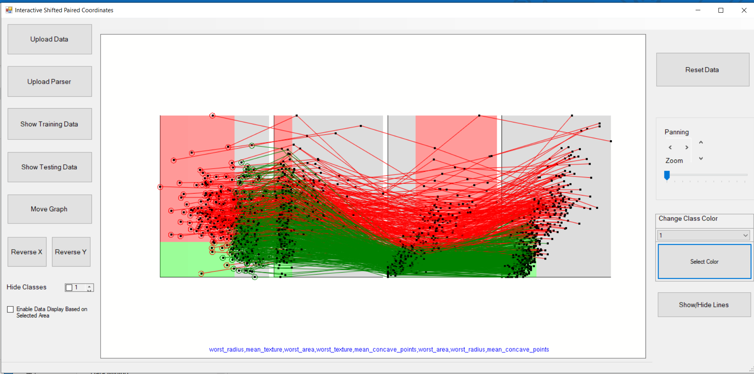

Figure 2.2.5: Visualization of breast cancer data after performing Reverse X on the first graph.

* After checking the ‘Enable Data Display Based on Selected Area’, the user can only display the data that belongs to a particular rectangle.

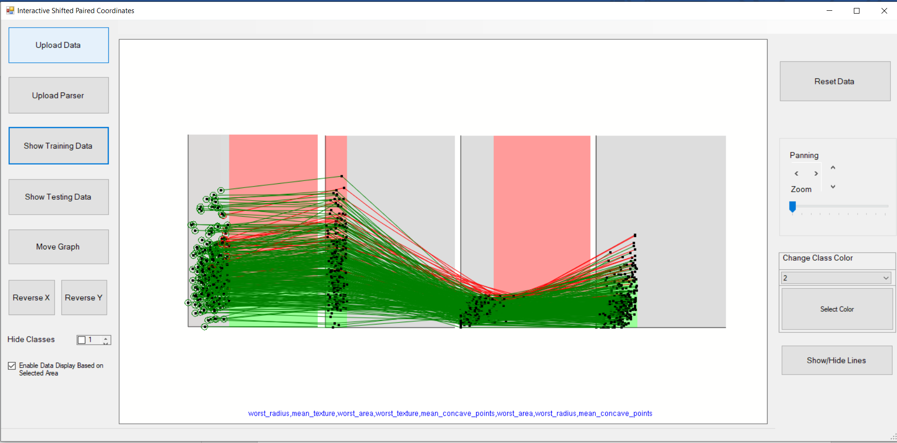

Figure 2.2.6: Visualization of breast cancer data belong to the grey rectangle for the first graph.

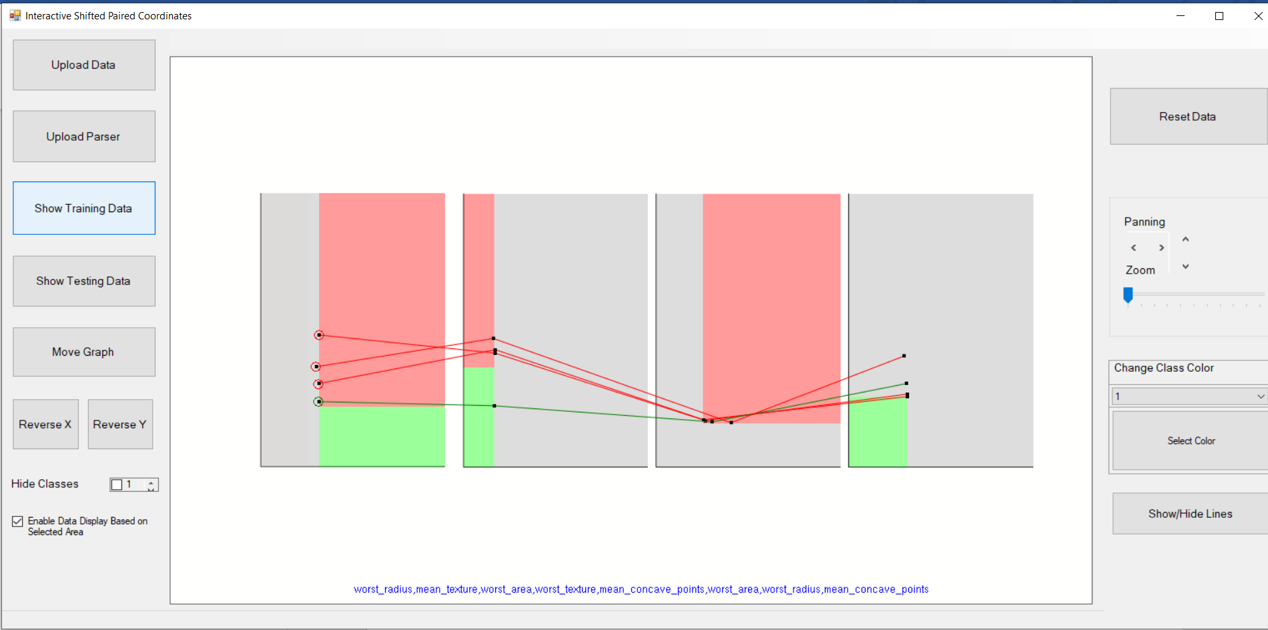

Figure 2.2.7: Visualization of breast cancer data belong to the grey rectangle for the first graph and red rectangle of the third graph.

# 3 Experimentation

## 3.1 Decision Trees in Bended Attributes

Figure 3.1.1 shows a decision tree trained on the breast cancer training dataset in Tanagra. Both the training and testing sets have been loaded and are displayed, with malignant target class colored red and benign target class colored blue. Transparency has been applied to the sample colors, making it easier to see the density of samples over the different tree branches.

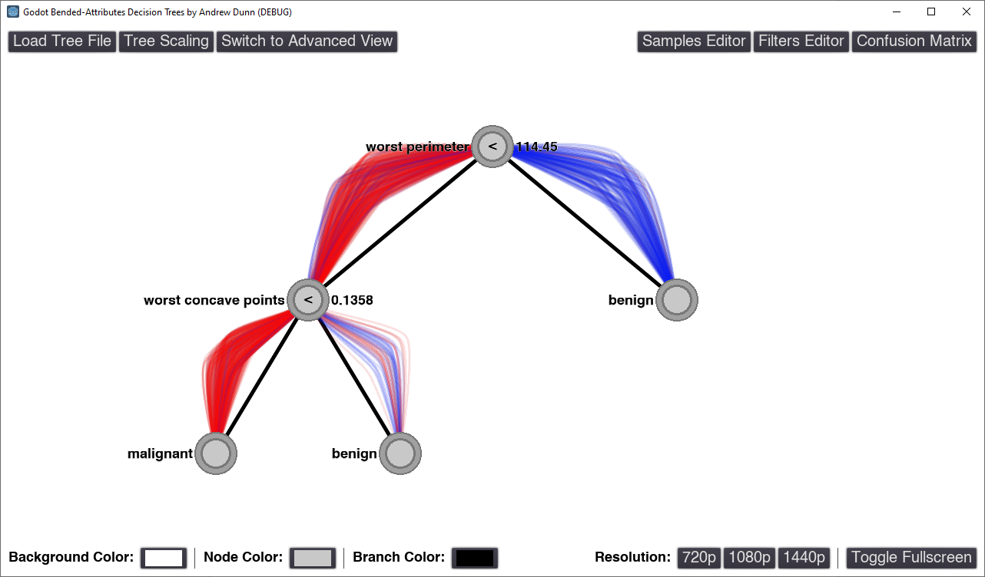

Figure 3.1.1: Tanagra Decision Tree using Breast Cancer Dataset (Both Test and Training Data)

Figure 3.1.2 shows the popup window after the left benign leaf node has been clicked. We can see that only 8.6% of all samples pass through this node.

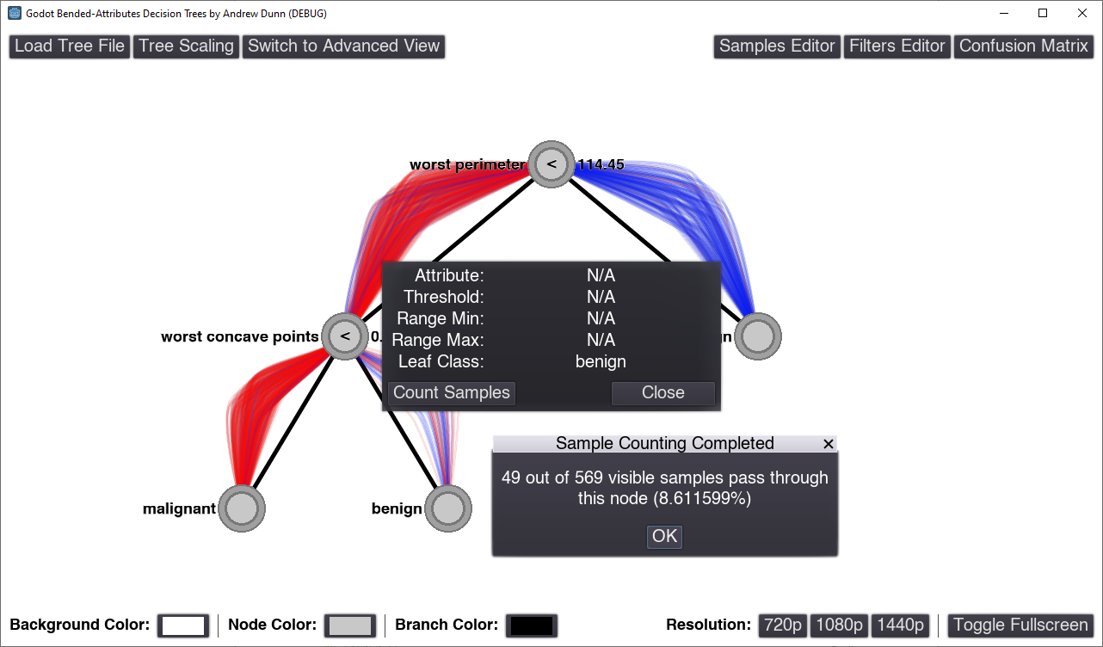

Figure 3.1.2: Automatically Counting Number of Samples Traveling to Benign Leaf Node

Figure 3.1.3 shows the same decision tree and data in Advanced Mode, which visually encodes sample attribute values in relation to each other and the node threshold by drawing the branch intersection point either closer or farther from the parent node.

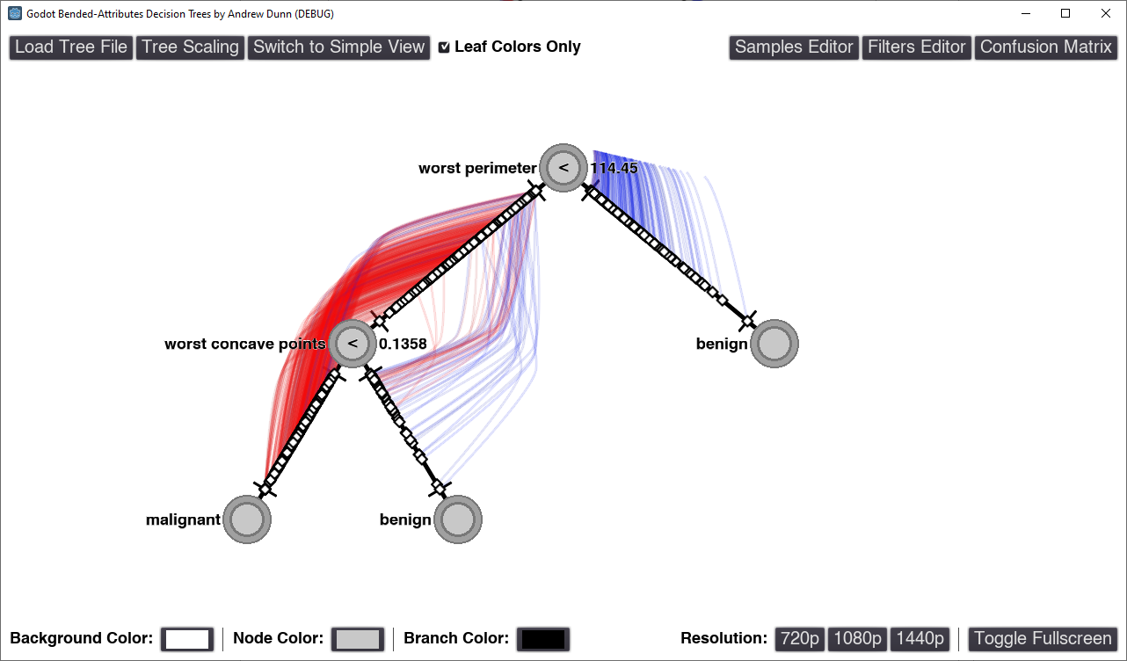

Figure 3.1.3: Advanced Mode with Transparency Applied

Figure 3.1.4 shows all incorrectly classified Benign samples after the filter has been applied. Here we can see that for the most of these samples are relatively close to the “worst concave points” threshold.

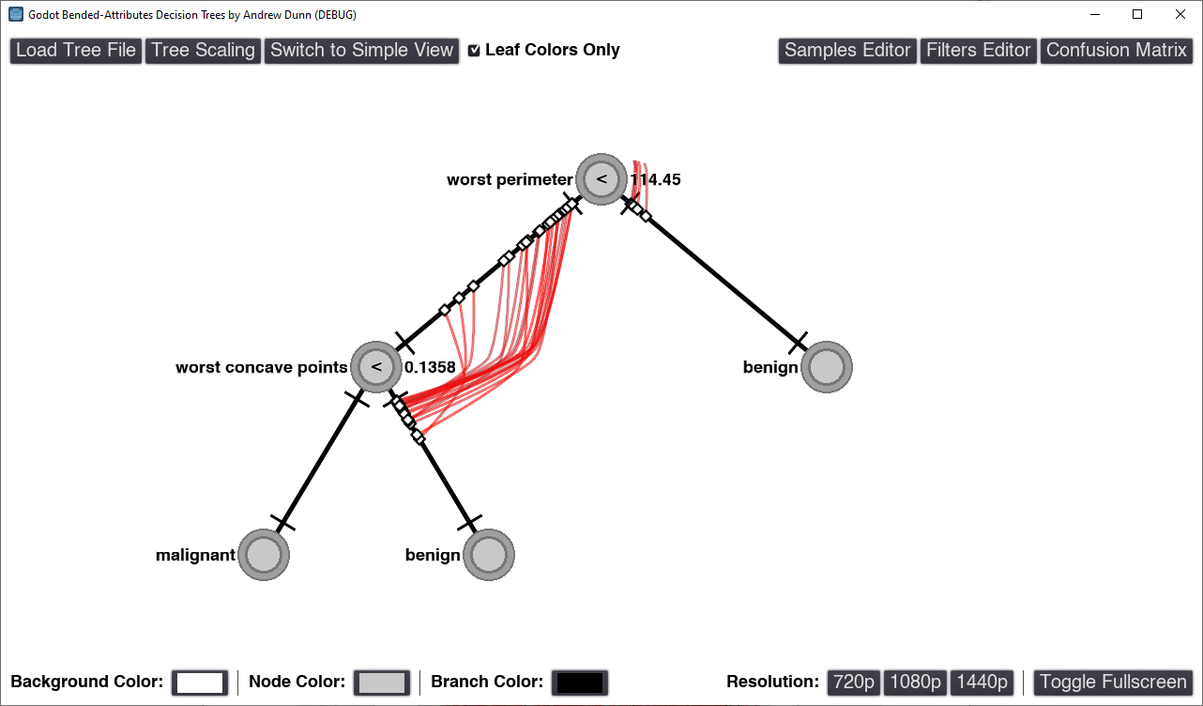

Figure 3.1.4: Left-over Samples After “Incorrectly Classified Benign” Filter is Applied

Figure 3.1.5 in contrast shows all incorrectly classified Malignant samples. For these samples, it is less consistently close to the threshold.

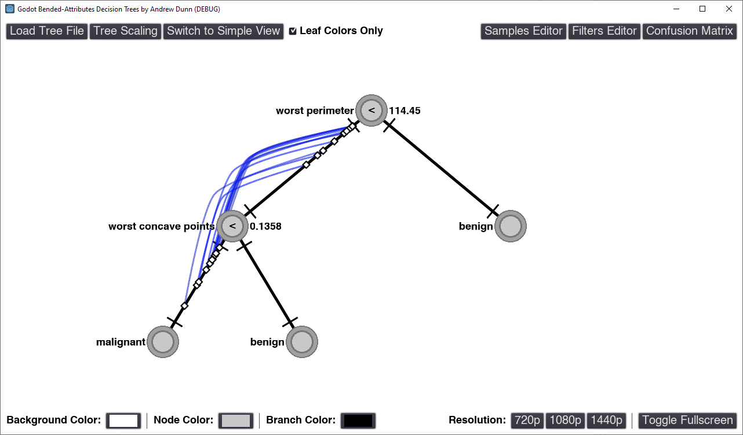

Figure 3.1.5: Left-over Samples After “Incorrectly Classified Malignant” Filter is Applied

Figure 3.1.6 shows the confusion matrix metrics for the training dataset, displaying an overall prediction accuracy of 93.8%.

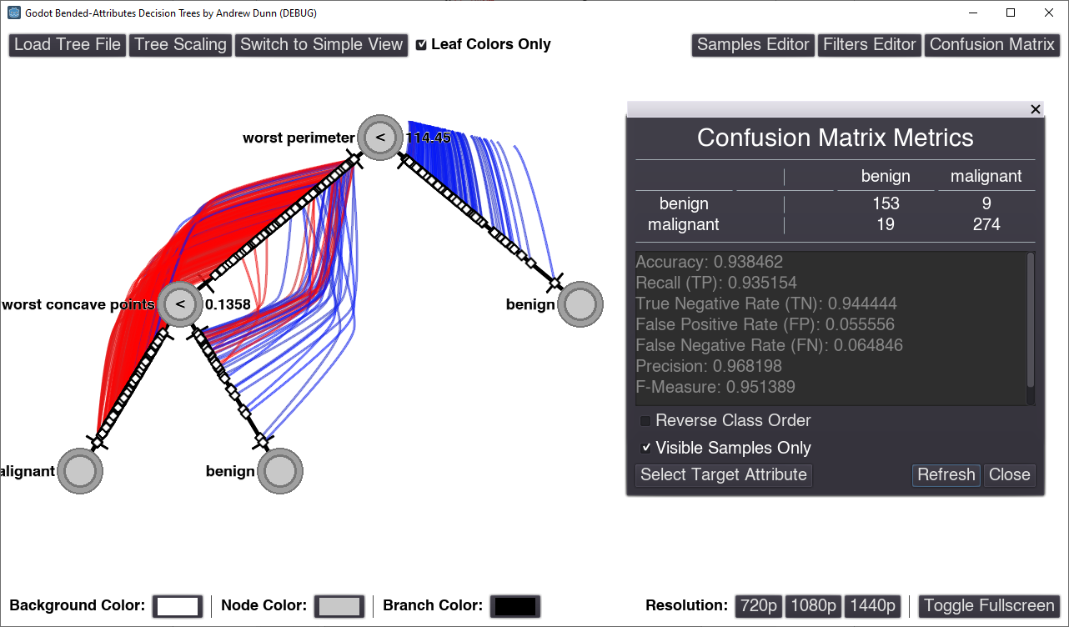

Figure 3.1.6: Confusion Matrix and Accuracy of Training Dataset After Applying “Training Set” Filter

Figure 3.1.7 shows the confusion matrix metrics for the testing dataset, displaying an overall prediction accuracy of 92.1%. Overall, the accuracy between the two is very similar.

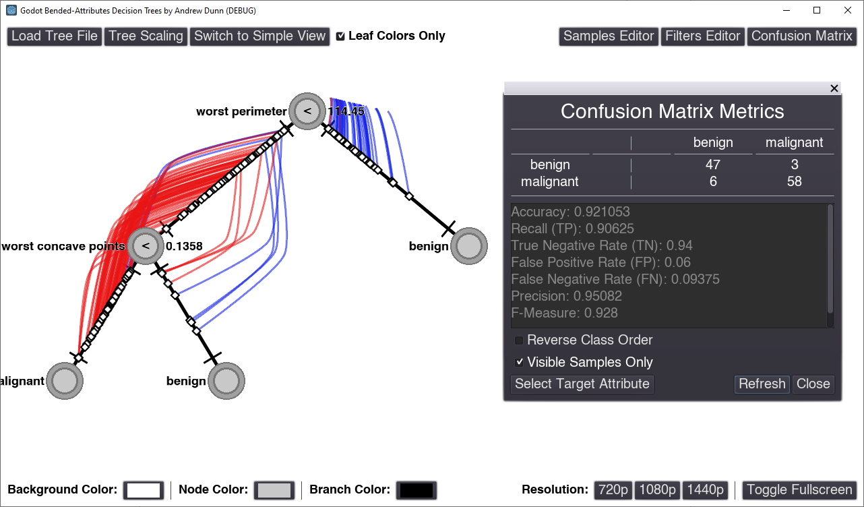

Figure 3.1.7: Confusion Matrix and Accuracy of Testing Dataset After Applying “Testing Set” Filter

## 3.2 Decision Trees in Shifted Paired Coordinates (SPC)

With the help of Shifted Paired Coordinate visualization, we can display the decision tree in terms of rectangular areas. We can classify the data that belongs to the red colored rectangle as class 1 (red) classification and the data that belongs to green class as class 2 (green).

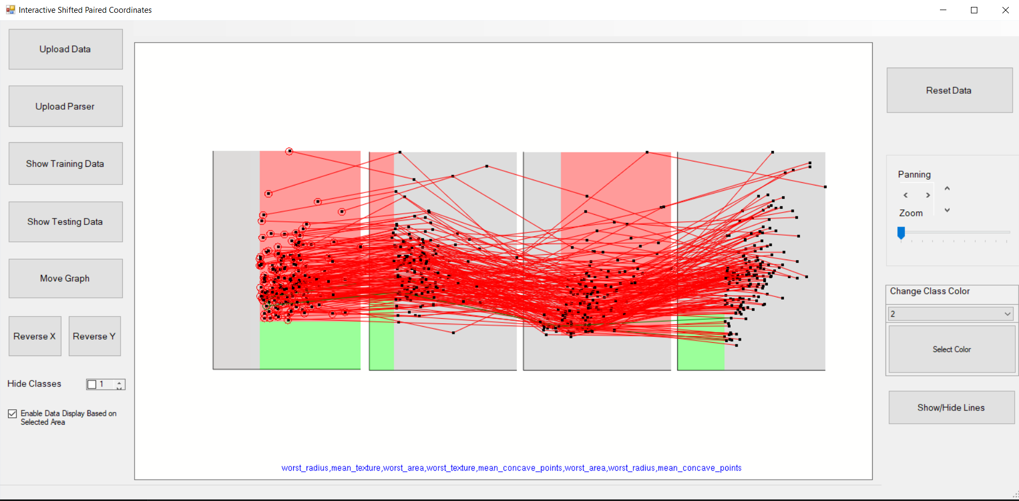

Figure 3.2.1: Visualization of breast cancer data belonging to red rectangle of the 1st graph

Figure above displays both red and green class data (green class is hidden behind red class data). We can also see that there are only few green lines within the red rectangle of the first coordinate pair.

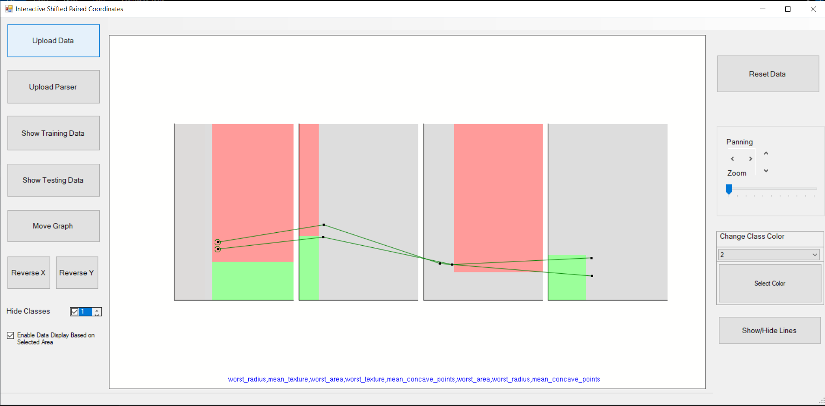

Figure 3.2.2: Visualization of only green class of breast cancer data belonging to red rectangle of the 1st pair of coordinates

Below figure displays seeds data with three classes along with the parser output for seeds data.

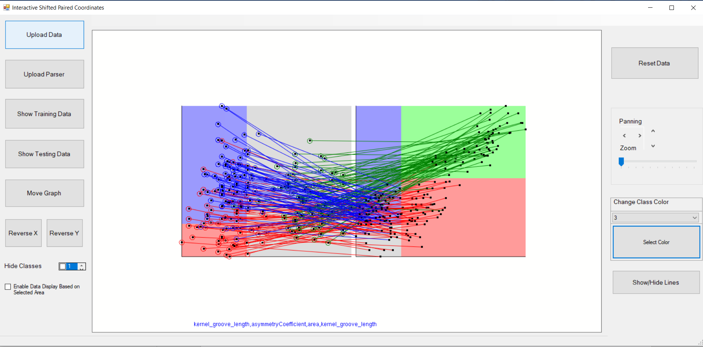

Figure 3.2.3: Seeds Dataset (4-D) with Tanagra output visualized in SPC

Figure below displays the data that belongs to blue (class 3) rectangle on the first pair of cartesian coordinates.

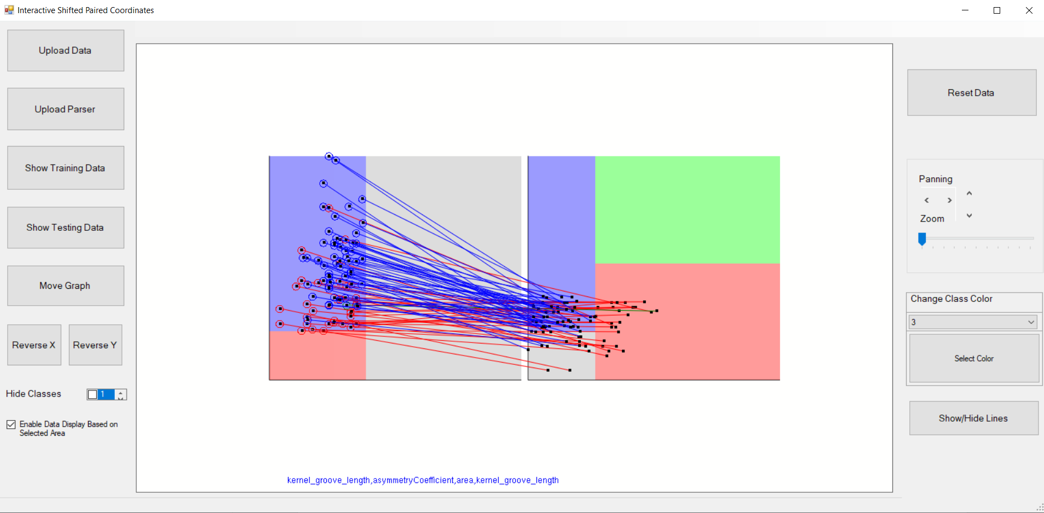

Figure 3.2.4: Visualization of data belonging to blue rectangle of the 1st pair of coordinates

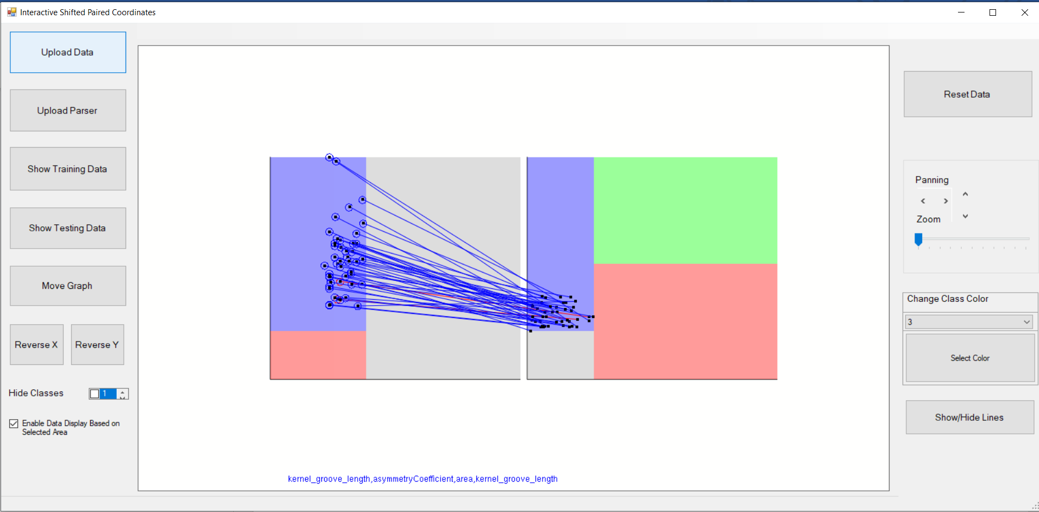

Figure 3.2.5: Visualization of data belonging to **both** blue rectangles of the 1st and 2nd pair of coordinates

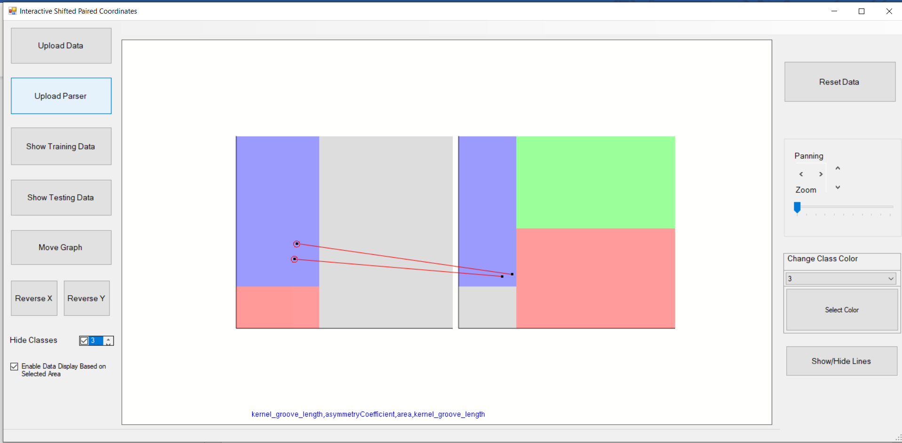

Figure 3.2.6: Visualization of red (misclassified) data belonging to **both** blue rectangles of the 1st and 2nd pair of coordinates

Figure below displays wine data with two classes along with the parser output for wine data.

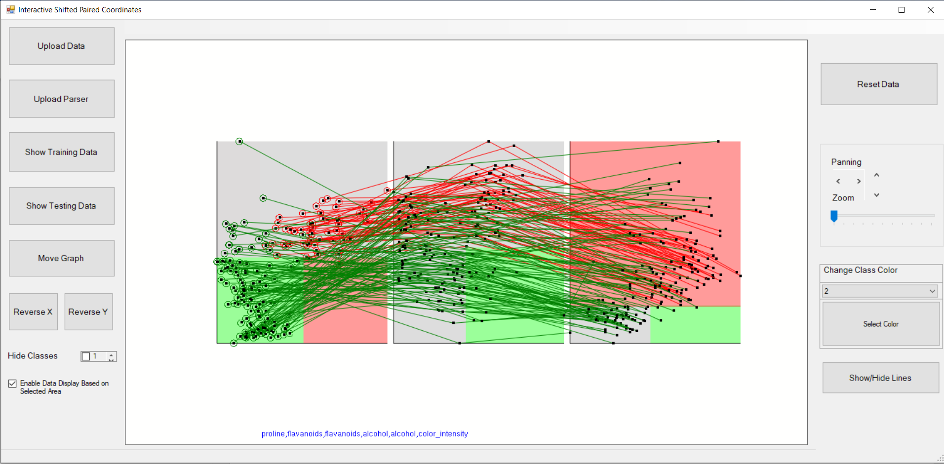

Figure 3.2.5: Wine Dataset (4-D) with Tanagra output visualized in SPC

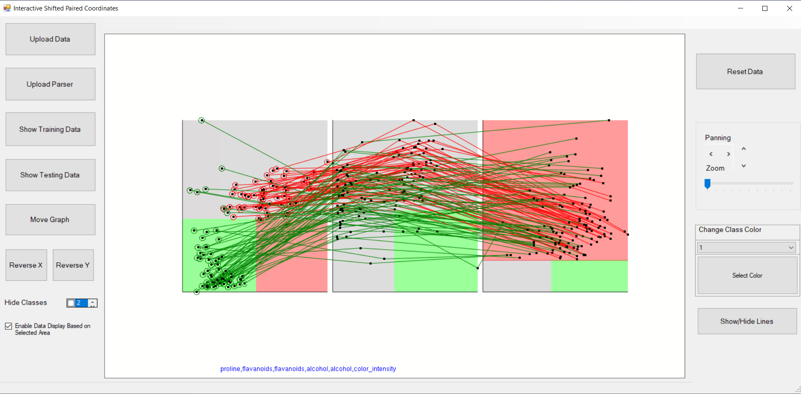

Figure 3.2.6: Visualization of wine data belonging to red rectangle of the 2nd pair of coordinates

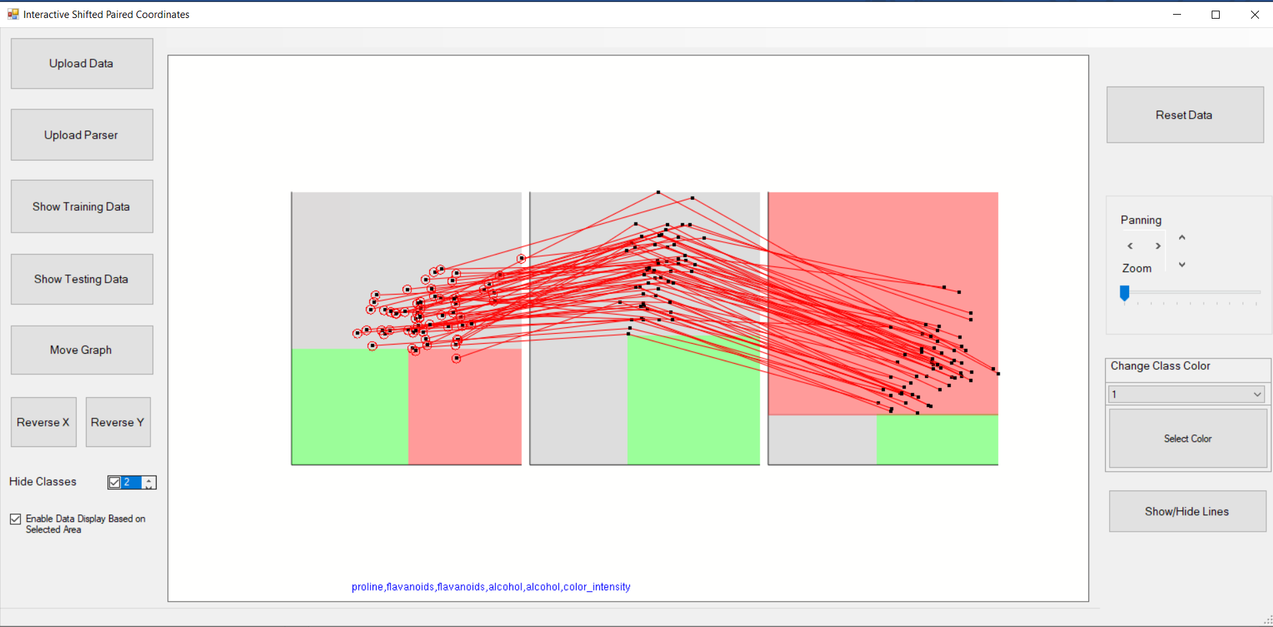

Figure 3.2.7: Visualization of (correctly classified) wine data belonging to red rectangle of the 2nd pair of coordinates

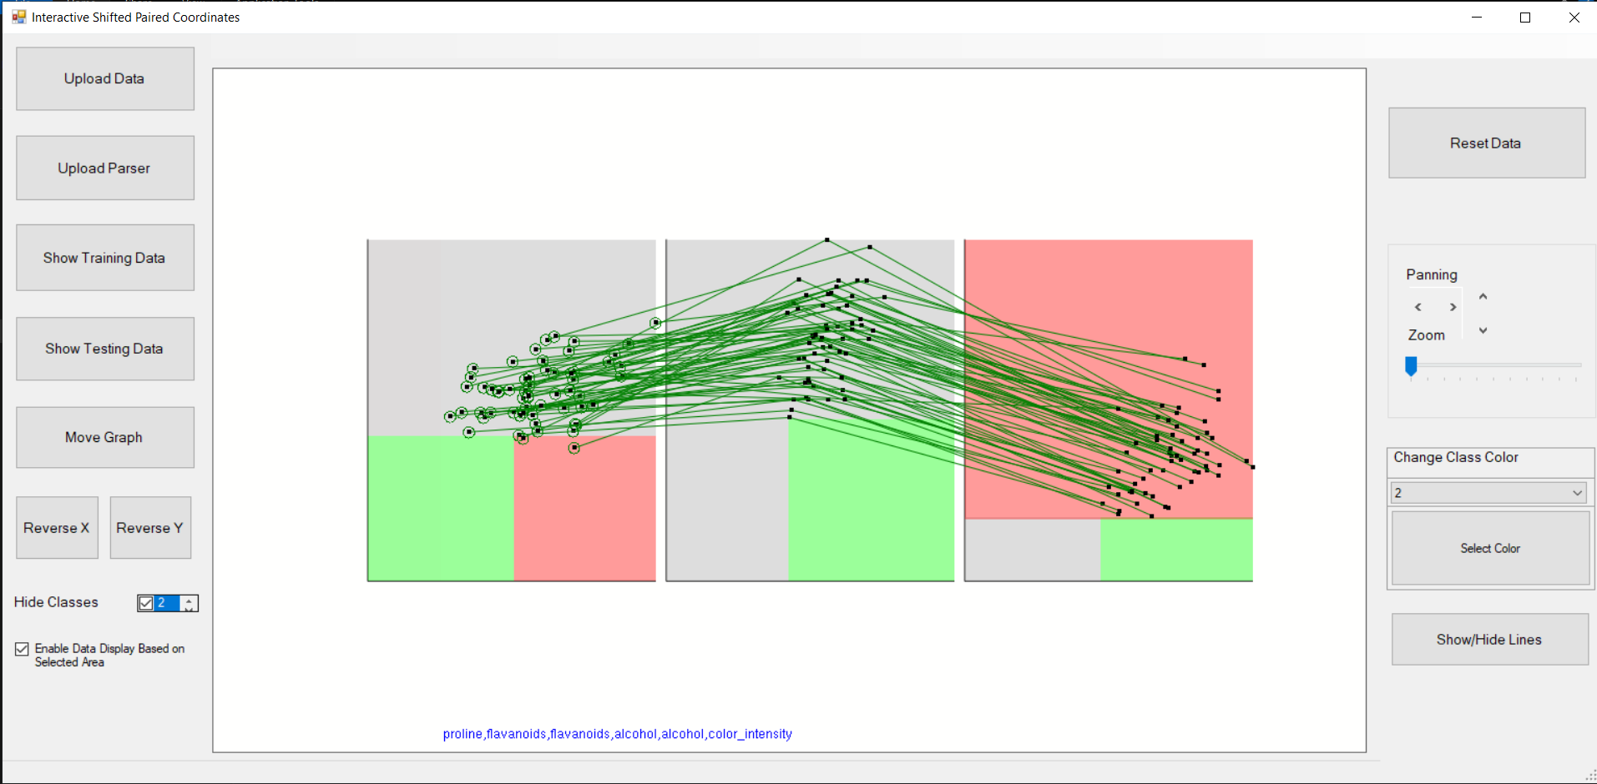

Figure 3.2.8: Visualization of green (misclassified) data belonging to red rectangle of the 2nd pair of coordinates

# 4 Comparison

* SPC provides a better representation compared to bended attributes for large dataset with less occlusion.
* Prediction of classes is better in bended attributes visualization than SPC since each leaf node represents one class, whereas in SPC, it is difficult to get the data points belonging to a particular rectangle especially when the rectangular areas are small.
* Bended attributes visualization is better for multi-class classification since each leaf node distinctly represents each class whereas in SPC, the nodes are represented in terms of rectangular areas. With more classes, there will be more rectangles making the classification more tedious in SPC.
* SPC visualization is better for representing the input data and relation between samples because points are mapped to a 2d coordinate system, whereas in bended attributes, visualization of data becomes more occluded.
* In bended attributes, only a single threshold value is considered at a time whereas in SPC, two threshold values are considered in pairs at a time.
* Bended attributes work for both odd and even number of attributes while SPC requires pairs of attributes. If there is odd number of attributes, one of the attributes need to be duplicated to represent it in SPC.
* Bended attributes only requires knowledge of decision trees to interpret the visualization, while SPC requires prior knowledge of the specific method to interpret the visualization.

# 5 Conclusion

The SPC and Bended Attribute visualization methods provide very different representations of the same decision trees and datasets. We found that both methods have their strengths and weaknesses when used as a visualization tool for identifying patterns in the data. We determined that SPC is a better representation of the sample data because it is clearer how the different attribute values relate to each other, since all points are graphed onto a 2D coordinate system. This makes it easy to see the relative distance between points, and their general distribution. We found that Bended Attributes is better at representing the decision tree model, since it is drawn as a binary tree. This makes it easier for the viewer to understand the decision-making process of the model and follow exactly how each prediction is made. In addition, we believe that understanding the SPC visualization method requires more training than understanding the Bended Attributes method, since it is less representative of the underlying tree structure. We believe that both visualization methods are useful, but one may be preferred over the other depending on if you are more interested in the relationships between data points or the performance of the model.